**English Worksheet.**

**Unit I – Information and Communication Technologies.**

**Instrucciones – Instructions:**

**- Evite los borrones y el uso de corrector.**

**\* Avoid smudges or stains and the use of correction pen.**

**- Responda utilizando los espacios destinados dentro de la guía.**

**\* Use the suitable area to complete each activity.**

**- Utilice solo lápiz de pasta (azul/negro) o grafito.**

**\* Use pen (blue/black) o pencil.**

**HABILIDADES – SKILLS:**

**- Leer textos y reconocer nuevo vocabulario en ambos idiomas.**

**\* Read the texts and recognize the new vocabulary in both languages.**

**- Leer textos, analizar información y desarrollar las actividades.**

**\* Read the texts, analyse the info and complete the activities.**

**STUDENT : _________________________________________________.**

**GRADE: 8TH GRADE ________ DATE: ____________________________.**

**MISTER JUAN CARLOS JARA R. Score: __________ Mark: ____________**

**1.- Reading Comprehension. Read the texts on the next page and recognize the new vocabulary. Complete the chart below.**

**2.- Reading Comprehension. Read the texts again and complete the activities.**

|  |  |  |  |
| --- | --- | --- | --- |
| **ENGLISH** | **SPANISH** | **ENGLISH** | **SPANISH** |
|  |  |  |  |
|  |  |  |  |
|  |  |  |  |
|  |  |  |  |
|  |  |  |  |
|  |  |  |  |
|  |  |  |  |
|  |  |  |  |

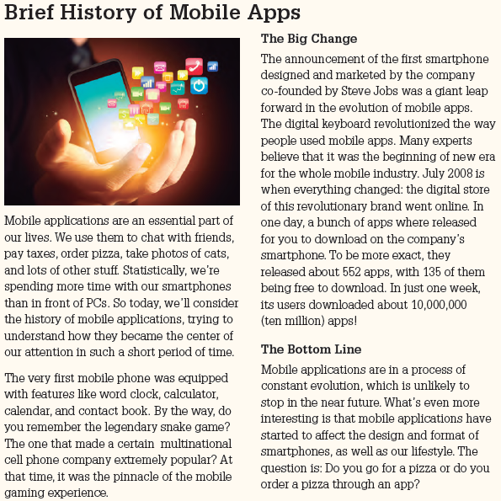

**a**.- Why are mobile applications an essential part of our life? (2pts)

__________________________________________________________________________________________________________________________________________________________________________________________________________________________________________________________________________________________________________________

**b**.- What features was the first mobile phone equipped with? (2pts)

___________________________________________________________________________________________________________________________________________________________________________________________________________________________________________________________________________________________________________________

**c.** Why was the snake game so important? (2pts)

__________________________________________________________________________________________________________________________________________________________________________________________________________________________________________________________________________________________________________________

**d.** What began a new era for the mobile industry? (2pts)

__________________________________________________________________________________________________________________________________________________________________________________________________________________________________________________________________________________________________________________

**e.** What is the future of mobile applications? (2pts)

__________________________________________________________________________________________________________________________________________________________________________________________________________________________________________________________________________________________________________________

**Match one sentence in the left column with one with the same meaning in the right column. (3 pts)**

1.- At that time, it was the pinnacle of the mobile gaming experience.

2.- The announcement of the first smartphone from the company co-founded by Steve Jobs was a giant leap towards the evolution of mobile apps.

3.- In one day, this revolutionary company released a bunch of apps…______ In a single day a cellphone company published a lot of applications.

______ In those days, you could not find a more advanced cell phone game.

______ The proclamation of the first cellphone of its kind was a huge advance in the development of mobile applications.

**Put the events below in chronological order. Write the answers from 1 to 5. (5pts)**

_____ Users of this brand, whose symbol is a fruit, downloaded a lot of apps.

_____ The new era for mobile industry began.

_____ Apps transformed smartphones and lives.

_____ The multinational cellphone brand was very popular.

_____ The first smartphone designed and marketed by the company co-founded by Steve Jobs was announced.